# **Maschine Jam Big Mapping Installation notes**

This Traktor mapping is for the Maschine Jam controller. It was designed as a companion to the NI Kontrol S5, but can be used alongside any controller. I used a Windows system but it should work happily on a Mac as well.

# What’s new at v0.55

The main change is the addition of the visualiser (see below). There are a few tweaks to the main mapping though, and they are;

* Deck mutes, the tempo, grid, solo and mute buttons act as mutes for decks a through d respectively. The nice thing about them is that they preserve the position of the volume faders when you toggle them off and on.
* Mixer FX selection, you can set the mixer fx per deck directly from the Maschine Jam. To use select page 1 of the mapping, on the right hand deck selectors choose the decks to alter and then press one of the following buttons; “browse”, “perform”, “notes”, “lock” and “tune”. “browse” will always select the filter, the others will choose the corresponding mixer fx that you have set in Traktor’s preferences.
* A bug fix, to set the sequencer length on page 2 or 4, hold down the “Note Repeat” button and press the appropriate step in the sequencer.

# Visualiser

At this version I have added integration with a visualiser app that is tightly linked to Traktor, responding to the audio signal as well as effect and filter settings. To use the visualiser you will need to refer to its specific documentation. The visualiser is written with the Processing framework (<https://processing.org/> ). It can be fiddly to set up and you should be comfortable with the Processing environment. Basic coding skills will help as well if you need to tweak it for your system. The code and documentation for the visualiser can be found at <https://github.com/cjkcjk01/GiantSpaceRobotVisualiser>, see the “README.md” file at the link for details.

# Prerequisites

So, you will need:

1. A Maschine Jam, set-up and connected to your computer via USB
2. The Native Instruments Controller Editor software, download from <https://www.native-instruments.com/en/support/downloads/drivers-other-files/>
3. Traktor, version 3.4.0 (or above)
4. To use the visualiser see the documentation at the github site linked above.

# Installation

To Install and configure follow the steps below:

1. Download the “Maschine Jam Big Mapping” zip file from [https://maps.djtechtools.com/mappings/6883#](https://maps.djtechtools.com/mappings/6883)
2. Unzip the file to any directory, it contains four files
   1. GSR - Effects v0.55.tsi – this is the setting file the effects for Traktor
   2. GSR - Maschine Jam v0.55.tsi – This is the controller settings file for Traktor
   3. GSR – Visualiser v0.1.tsi – this is an additional settings file, only needed if you want to try the visualiser functionality
   4. GSR traktor 0.55.ncmj – this is the Machine Jam template file
3. Let’s start with the Maschine Jam setup.
   1. Make sure that the hardware is connected and launch the “Native Instruments Controller Editor” software. In the top left of the app is the device list, browse to your Maschine Jam and click Connect, it should look like the image below: 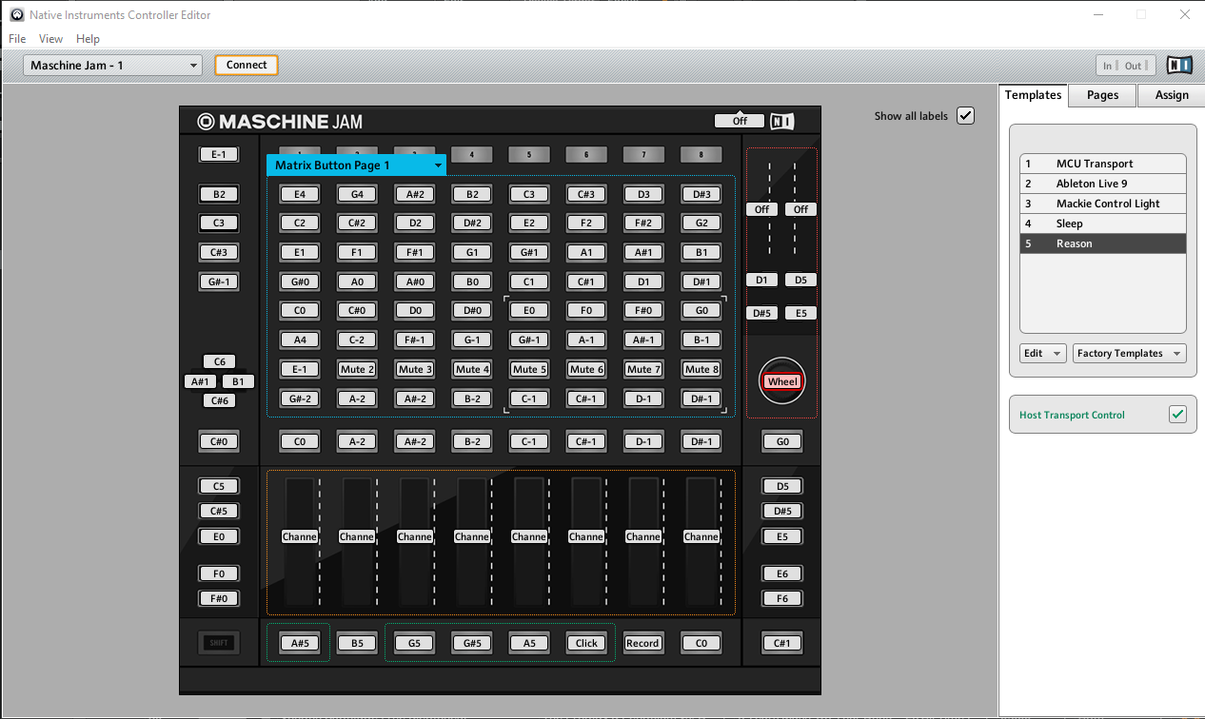
   2. In the “Templates” Panel on the right click the “Edit” button and select “Open”. Browse to the “GSR - Traktor 0.55.ncmj” file and click “Open”
   3. The panel will now have the “GSR - Traktor 0.55” template in it. Select this and the buttons on your Maschine Jam should change to the new setup. Now is a good time to use “File->Save Configuration” to keep these changes.  
       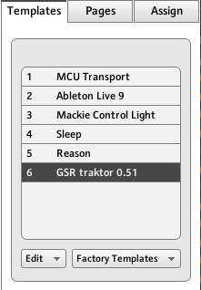
4. Now let’s move to Traktor:
   1. Launch the program and open the “preferences” dialog, either via File->Preferences or the cogwheel button in the top right of the app.  
      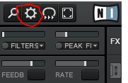

Before we move on, let’s discuss effects.

You have two choices here, either use the effects settings you already have, or load the ones that I have used. If you decide on the former, then you will need to manually set the correct effect to the appropriate button. You do this by editing the mapping once it is loaded. I have put the expected effect in the Comment field of the mapping so that you can do this easily.

To load my effects settings do the following:

Select “Import” at the bottom of the preferences dialog, the file selection dialog will open.

Browse to the GSR - Effects v0.55.tsi file and click “Open”, the Import dialog will then appear

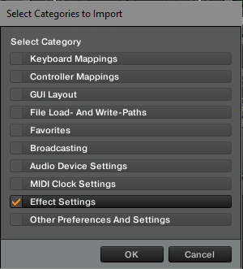

Click on OK and the effects settings will be loaded.

I don’t think this is a big deal either way, if you are concerned then back up your existing settings using the “Export” option before you start.

1. Select “Controller Manager” in the left frame of the preferences dialog.  
    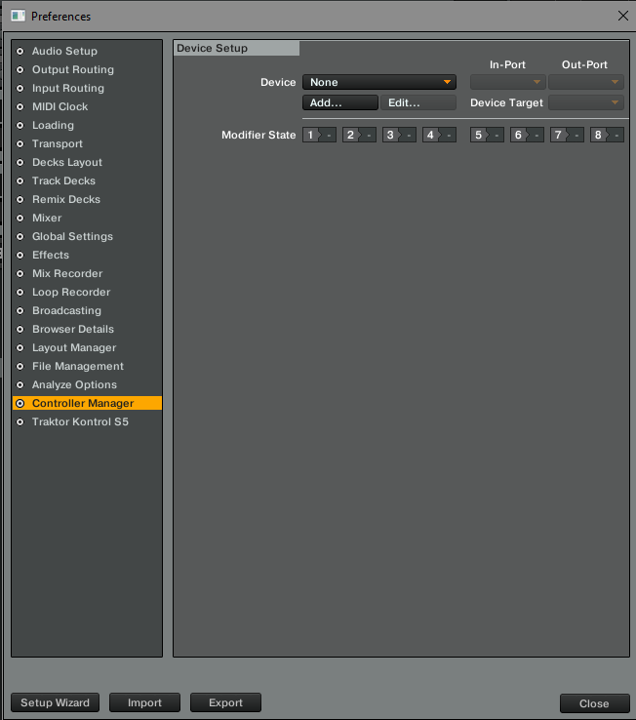
2. Now we need to import the settings file, use the “Add…” button in the device setup area of the dialog.  
   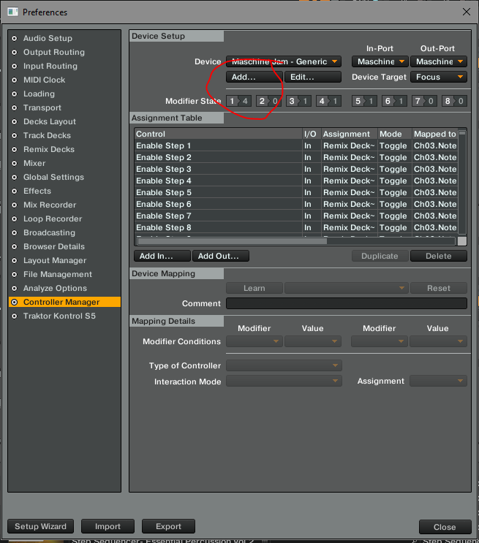
3. Select “import TSI” and then “Import Other…”.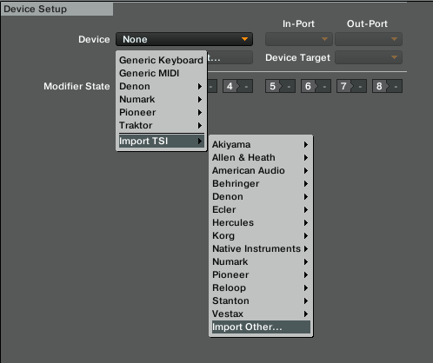
4. Browse to the “GSR - Maschine Jam v0.55.tsi” file and click “open”.
5. If that worked, then you will see something like the image below. Make sure that the “In-Port” and “Out-Port” are set to your Maschine Jam 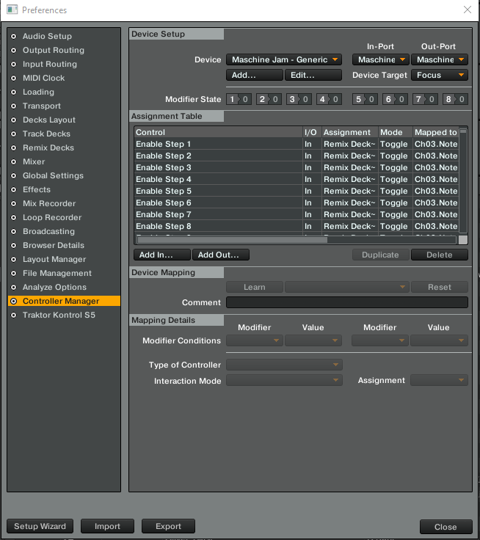
6. The lights on your Maschine should now change to look like those in the video. Press a few buttons to make sure it is working, you should see the “CTRL” indicator light  at the top of Traktor light up, this shows that the controller is talking to Traktor OK. If not, then try restarting Traktor.
7. If you want to use the visualiser then repeat the steps above with the “GSR Visualiser v0.1.tsi” file. Its midi in-port should be “none” and the midi out-port should be set to a virtual midi port on your machine (see the visualiser specific doc for details on this).

Its good practice to hit the “Select” button on the bottom right of the Jam when you start, it basically resets the controls to their defaults ready for you the play.

# Finally

If you want to modify the mapping then it is best to make the “preferences” dialog as big as you can, by clicking on the bottom right corner of the dialog and dragging it out. Then drag the Comment column wide enough to actually see the comments. Now click on the Comment column header to sort the entries by the comments.

One thing to check is that the correct effects are being used. (Traktor seems to sometimes mess these up when exporting and importing, I think it only exports the effects that are currently set, rather than the list of ones that are available. In the comments I have put the specific names of the effects that should be set. Make sure that the comment and the “Set to value” match up

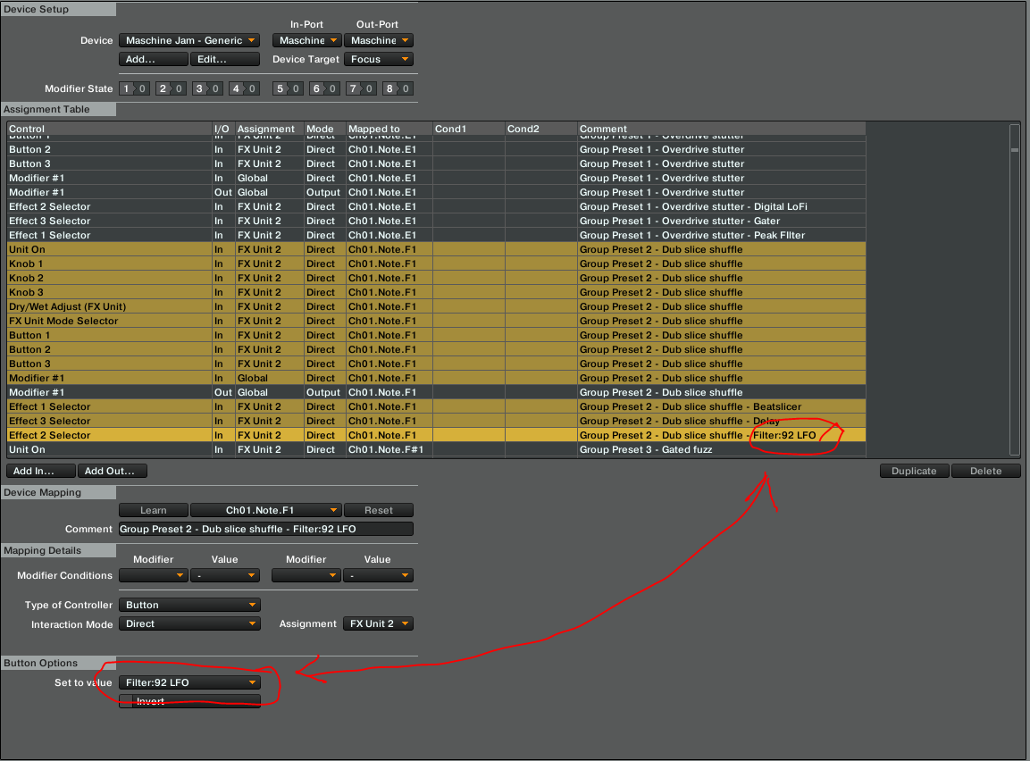

Because there are a lot of entries the editing in Traktor is really slow, you need a lot of patience. I use the CMDR editor as it is faster and more functional than the built in editor.

Good luck

GiantSpaceRobot